**Title : Jump Project**

**Contributions:**

Member 1 Juan Sanchez Roa :

For this project, I worked on creating a tree classifier for the data, creating features, extracting features, and combining all the data. I also printed out the decision tree, printed the confusion matrix and worked on the sensor logger python file to test the code real time.

Member 2 Divakar Borra:

For the final project, I contributed by collecting data and by helping with the code to smooth the data. I also helped by creating visualizations of the data and I helped with the creation of the decision tree. I also help with the creation of the final presentation.

Member 3 Amira Garba:

I contributed to this project by working on sections of our final report and revising our work. I’ve also helped in the code by removing the noise from the data collected and plotting some of the graphs as well as writing some code to identify features in the graph.

**Problem Statement**

When it comes to fitness, form and quality is more important over quantity in reps someone does. The point of exercises is to target certain muscles or groups of muscles and work them until they break down and repair. This involves pushing participants and their bodies. During this time their form and quality could decrease which will lead to an ineffective workout. Our project centers around jumping; jump detection is essential for evaluating the efficacy and standard of exercise programs. The goal of this project was to create a mobile health sensing application that used an accelerometer to record jump data and assess the quality of each jump. The application will analyze the user's jump technique during various fitness activities, such as jumping jacks, squat jumps, or box jumps. It will utilize motion analysis algorithms to evaluate the form and quality of each jump, providing feedback on whether it was executed correctly or needs improvement. This could also be used as a way to determine improvements in workouts. For beginners they might do as well in terms of quality in workouts but the continuation of said workout could lead to better workouts and this project could help keep track of it.

**Potential Applications of the Project**

Our mobile health sensing application can be used for a large variety of applications in fitness, healthcare, rehabilitation, and research fields. It empowers individuals to take control of their health, enables remote monitoring and guidance by healthcare professionals, and contributes to advancing knowledge in the field of exercise science.

1. Fitness Tracking and Performance Enhancement: During workouts, fitness enthusiasts can use the application to track their heart rates, activity levels, and jump quality. Users can monitor their development over time, pinpoint their areas for growth, and modify their training schedule to increase performance.
2. Personal Health Management: As part of their health management strategy, people with certain health issues, such as obesity or cardiovascular disease, can use the program to track their heart rates and activity levels. It can give them information on how well their training regimens are doing and assist them in deciding on their fitness objectives.
3. Employers can use the application in corporate wellness initiatives to motivate staff to maintain an active lifestyle and track their fitness levels. To encourage employees to lead healthier lifestyles, the application can give incentives, track engagement, and provide individualized feedback.
4. Research and Data Analysis: The application's data collection allows for the study of workout patterns, the analysis of jump quality trends, and the identification of variables that influence performance or put athletes at risk for injury. The data can be used by researchers and fitness experts to improve workout plans and improve training methods.

**Data Collection, Model Training, and Testing/ Analysis**

1. The program can make use of the accelerometer sensors found in mobile devices or compatible wearable devices to gather data for leap detection. These sensors have the ability to measure rotation and acceleration, enabling the application to follow the user's movements as they jump.
2. Accelerometer readings from the obtained raw sensor data can be time stamped and linked to each jump the user makes.
3. Model Training:
   1. The following steps make up the model training procedure for jump detection:
      1. Data preparation To extract useful characteristics for the model's training, the raw sensor data needs to go through some preprocessing. The data may then be normalized, segmented into individual jumps, and filtered to reduce noise.
4. Feature Extraction: To reflect the properties of a jump, meaningful features must be retrieved from the preprocessed sensor data. These characteristics may include the height of the jump, its length, its force, and other metrics that reflect the quality of the jump.
5. Labeling: Based on preset criteria, each leap in the obtained data must be classified as either a "good jump" or a "bad jump."
6. Model selection: For this section we used machine learning for jump detection ; specifically we used decision trees, and random forests for our models. The choice is made based on how complex the data is and how well it will function.
7. Data Split: Training and testing sets of the labeled data can be created. The testing set is used to assess the model's performance and generalizability while the training set is used to train the model.
8. Model Training: Using the labeled training data, the chosen model is trained. Based on the retrieved features, the model develops a "good" or "bad" classification for jumps.
9. Model validation: Using the labeled test data, the trained model's performance is examined. Performance metrics for the model include accuracy, precision, recall.
10. Iterative Refinement: By tweaking the model architecture, modifying the hyperparameters, or adding new features, the model's performance can be further enhanced. The accuracy and generalizability of the model are improved through this iterative approach.

**Analysis and Tests:**

The mobile health sensing application can use the trained and verified model for real time jump detection during physical activity. Users can leap, and the program will evaluate sensor data in real time to categorize each jump as "good" or "bad."

The program may give users immediate feedback on the caliber of each jump. Based on the feedback, users can modify their technique, maintain good form, and strive for higher performance.

The gathered information can also be utilized for further research to spot patterns in jump quality, find relationships between jump characteristics and other fitness indicators, or assess how well various training regimens work. To extract useful insights from the gathered data, statistical analysis, data visualization methods, and machine learning algorithms might be used.

It's crucial to keep in mind that the specific methodology, algorithms, and procedures employed for data gathering, model training, and analysis may vary based on the project's needs and available resources. For this project particularly we focused on our group member Divakar where he performed the activities and recorded himself. With more use, more data can be gathered and the classifications will become more accurate.

**Results**

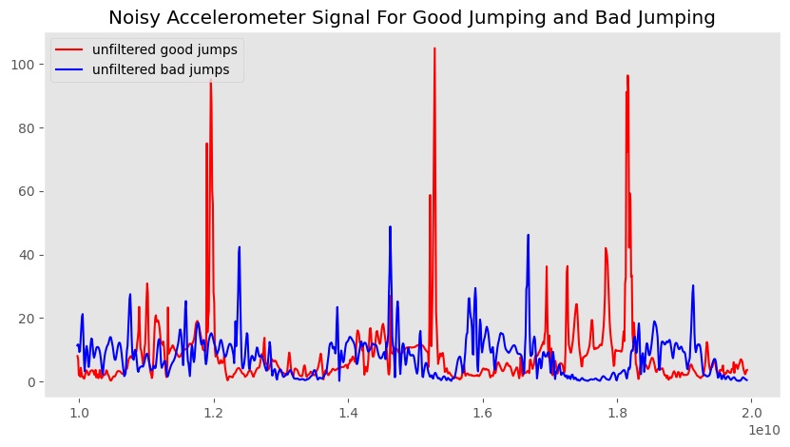

We have captured the unfiltered signal of both good and bad jumps in this graph. During the initial analysis, we contemplated which features to prioritize in distinguishing between good and bad jumps. While it seemed logical to focus on the actual jumping phase of the graph, we discovered a more prominent feature that makes it easier and more apparent to differentiate between the two labels: the landings.

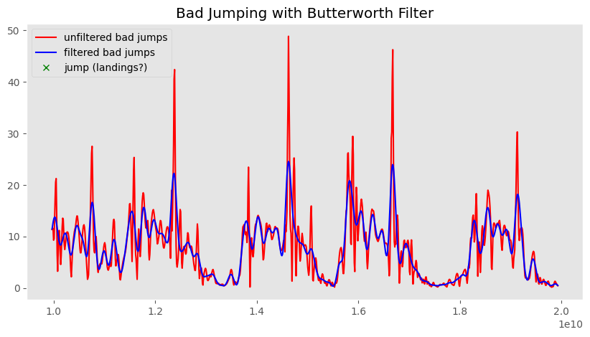

We utilized the Butterworth Filter on the raw signal of our jumping data, separately for both the dataset containing good jumps and the one containing bad jumps. By removing the noise, we obtained a filtered graph.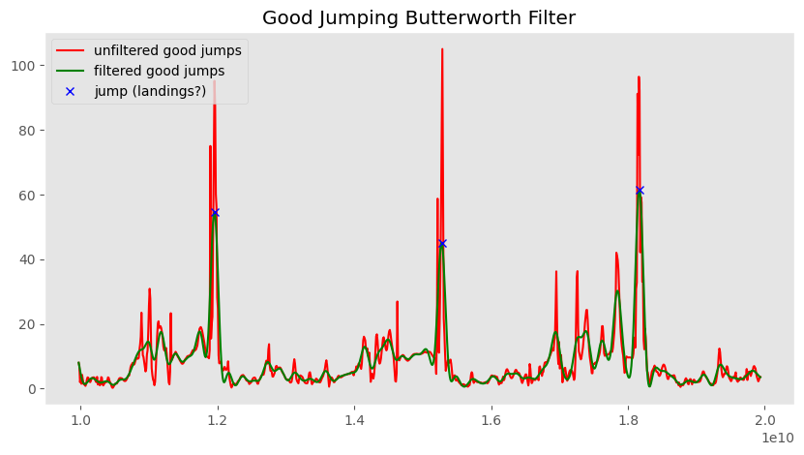

In this graph, the taller spikes represent the landings following each jump. The height of these spikes indicates the height and quality of the jump. Although it may appear that the peak heights are the same in both graphs, it's important to note that the Y-axes are different. Good jumps reached approximately 100 on the accelerometer, while bad jumps peaked at around 50.

.

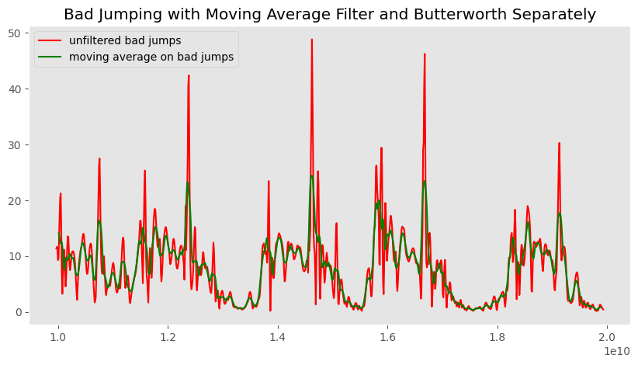

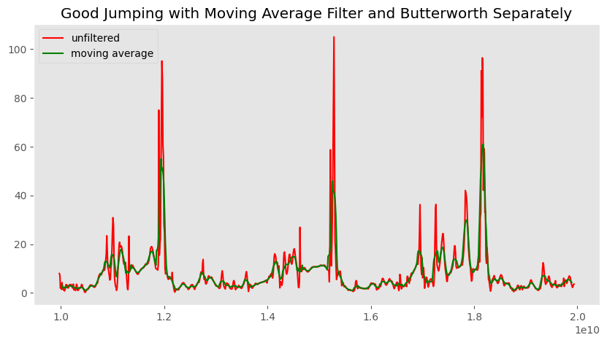

In the following two graphs, we employed a different filtering method known as the moving average. However, after evaluating its performance, we concluded that the Butterworth filter was a better choice. The Butterworth filter demonstrated better preservation of the essential features compared to the moving average filter.

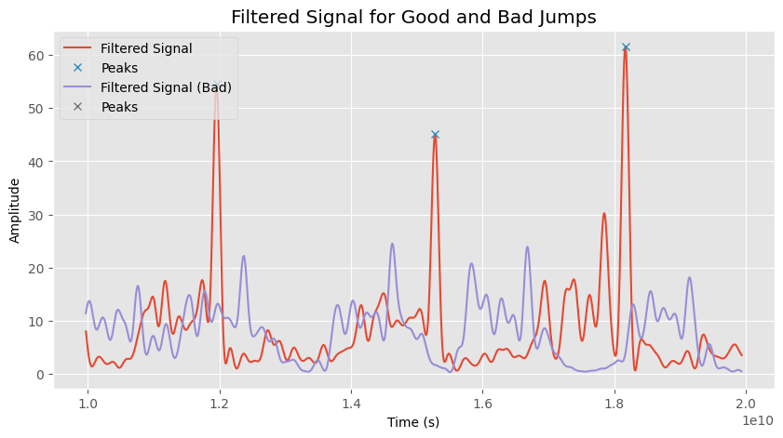

Here is the resulting filtered signal for both good and bad jumps, with the labeled good jumps indicated. As anticipated, we successfully identified and labeled three jumps using the combined information from both graphs.

Decision Tree:

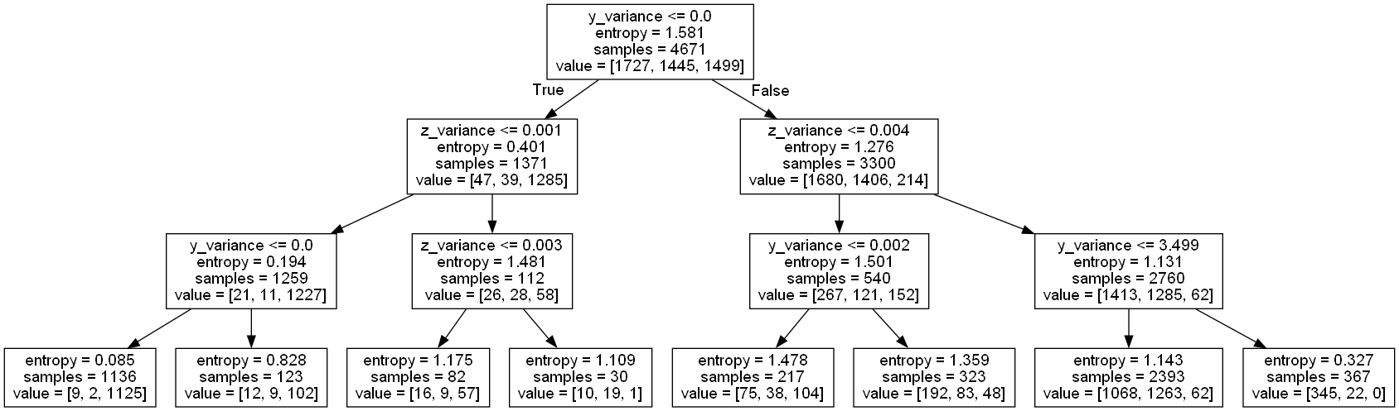

Using the decision tree approach, we calculated the variance, mean, and entropy from the files of various sessions containing both good jumps and bad jumps. These features were derived from the data to aid in the classification and differentiation between the two types of jumps.

Confusion matrix:

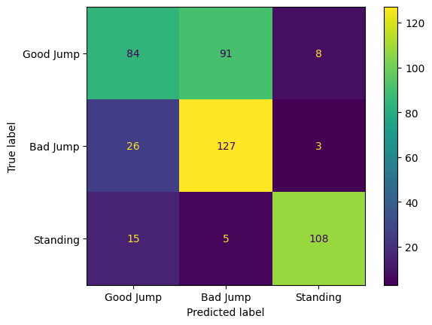

**Avg Accuracy: 0.67567, Avg Precision: 0.54190, Avg Recall: 0.86638**

Using a confusion matrix, we calculated the recall, precision, and accuracy. We saw that the confusion matrix was somewhat accurate. It saw that a bad jump got confused a lot for the good jump. It was also seen that standing was confused as a good jump as well.

**Learnings from the Project**

The goal of this project was to create a smartphone application that accurately judges whether a jump is excellent or poor by using sensors. An understanding of jump assessment and its use in the field of fitness tracking and performance monitoring was improved through the process of data collecting, model training, and analysis.

It was crucial to select the right sensors, including accelerometers, for precise jump detection. The mobile application's integration of this sensor gave it the data it needed to record the movements and traits of each jump.Effective preprocessing methods were used to obtain clear and trustworthy data. These methods were designed to eliminate noise, outliers, and artifacts from the sensor data that had been gathered. By eliminating unwanted interference, the quality and accuracy of the jump assessment process were improved.

The key properties of jumps were effectively captured by the feature extraction procedure. The production of informative inputs for the jump evaluation model was made possible by the extraction of significant properties, such as jump height, duration, power, or symmetry. These characteristics offered crucial indications to distinguish between good and bad jumps.

The jump detection model was trained with the help of labeled data, where leaps were manually categorized as good or bad. Automatic labeling based on real-world data was used in this approach. The annotated data made it easier to train and test the model and allowed it to pick up on the patterns and traits of both excellent and bad jumps.

The project included investigating different machine learning models for jump detection. The effectiveness and applicability of various models, including decision trees, and random forests were assessed. The complexity of the data and the necessary accuracy were taken into account when choosing the model. Model performance was assessed by model validation utilizing the right measures, including accuracy, precision, recall. The model's performance was greatly enhanced by the iterative refining procedure. The accuracy and robustness of jump detection were improved by fine-tuning the model's architecture, tweaking hyperparameters, and introducing additional features or approaches. The performance of the model could be continuously enhanced and optimized thanks to iterative refinement.

A crucial feature of the mobile application was giving users immediate feedback on the caliber of their leaps. Each jump's classification as good or terrible was shown visually by the application, which also displayed the assessment findings. Users were driven to improve their training methods and make quick adjustments to their leaps by real-time feedback and visualization.The gathered data offered chances for additional analysis and insights. To find trends, relationships, and factors affecting jump quality, statistical analysis, data visualization, and machine learning approaches were used. These studies aided in developing a deeper comprehension of the effects of numerous aspects on the caliber of jumps and assisted the making of well informed decisions.

The project underlined the value of personalized, user-centric design. The application was made more user-friendly and efficient by giving users the option to alter the jump assessment criteria and create recommendations based on their unique goals and development. Individualization is ensured

**How to Improve the Project Further:**

We came up with two primary ideas on how to recognize excellent or bad jumps more precisely in order to further develop the project:

1. Jump detection algorithm improvement: The model can be improved by tweaking its architecture, changing its parameters, and adding more characteristics designed especially for evaluating jump quality. The accuracy and dependability of the findings of the jump detection can be increased by this recurrent refinement procedure.
2. Increasing the dataset's diversity: assemble a bigger and more varied dataset of jumps made by people with different degrees of fitness, body types, and jumping styles. The model may be trained to recognize and distinguish between good and bad jumps in a larger range of scenarios thanks to the increased dataset.

**References:**

We mostly referenced class code when constructing the python files for the project.

The following links are references utilized for this project that were specifically related to the importance of jumping exercises in fitness routines and explored various applications and projects in this domain. These sources provided valuable insights into the benefits of incorporating jumping exercises into workouts and offered information on different projects and applications centered around jumping exercises.

1. <https://www.ncbi.nlm.nih.gov/pmc/articles/PMC4974862/>
2. <https://www.12minuteathlete.com/jumping/#:~:text=Jumping%20on%20a%20regular%20basis,to%20keep%20your%20heart%20healthy>.
3. <https://www.medicinenet.com/what_are_the_benefits_of_jumping/article.htm>
4. <https://starfishtherapies.com/2021/02/jumping-activities/>